**MIP 280A4: Microbial Sequence Analysis**

**Phylogenetic Trees part 2, In-class exercise questions**

1. Create a NJ tree in Geneious using your multiple sequence alignment of 34 flavivirus NS5 protein sequences from last time. Based on this tree, what is the most closely related virus to the two Zika virus sequences? (1 pt)
2. Now, create a NJ tree with 100 boostraps in Genious from the same alignment. Is the answer to the previous question well supported by this bootstrapping analysis? In how many of the 100 bootstraps was this virus a closest neighbor to the two Zika sequences? (1 pt)
3. How is the bootstrapped tree you created in the above question rooted? (1 pt)
4. Describe one strategy you could use to root this NS5 tree. (1 pt)
5. Draw all of the different rooted trees you could draw that contain these three taxa (feel free to use abbreviated virus names). (1 pt)

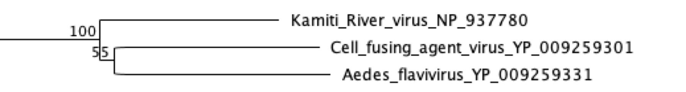

1. Based on the presented bootstrap values, what would you conclude about the reliability of the branching pattern for the branch labeled A in the tree below? (1 pt)



1. What would you conclude about the reliability of the branching pattern for the branch labeled B in the tree above? (1 pt)
2. Describe one property of evolution that might differ between different models of nucleotide evolution. (1 pt)